MALWARE AND THREAT DETECTION

TYPES OF PASSWORD ATTACKS
TASK1: Create a simple HTML login form with username and password fields, then write a JavaScript function that simulates a brute force password attack by trying a list of 5 common passwords to guess the correct one.
HTML CODE:
<!DOCTYPE html>
<html>
<head>
<title>Login Form</title>
</head>
<body>

<h2>Login Form</h2>

<label>Username:</label>
<input type="text" id="username"><br><br>

<label>Password:</label>
<input type="password" id="password"><br><br>

<button onclick="login()">Login</button>

<p id="result"></p>

<script>
function login() {
let correctPassword = "admin123";
let enteredPassword = document.getElementById("password").value;

if (enteredPassword === correctPassword) {
document.getElementById("result").innerHTML =
"Login Successful";
} else {
document.getElementById("result").innerHTML =
"Incorrect Password";
}
}

function bruteForceSimulation() {
let passwords = [
"password",
"123456",
"qwerty",
"admin",
"admin123"
];

let correctPassword = "admin123";

for (let password of passwords) {
document.write("Trying: " + password + "<br>");

if (password === correctPassword) {
document.write("<b>Password Found: " + password + "</b>");
break;
}
}
}
</script>

<button onclick="bruteForceSimulation()">
Run Brute Force Simulation
</button>

</body>
</html>
How it works:
- The login form accepts a username and password.
- The correct password in this example is admin123.
- The simulation has 5 sample passwords.
- JavaScript checks them one by one.
- When admin123 is found, the simulation stops.
OUTPUT:
Trying: password
Trying: 123456
Trying: qwerty
Trying: admin
Trying: admin123

Password Found: admin123
TASK2: Write a Python script that takes a list of 10 leaked passwords (e.g., 'password', '123456', 'qwerty', etc.) and checks if a user's input password matches any password in the list, simulating a dictionary attack.
# Sample leaked/common passwords
password_list = [
"password",
"123456",
"qwerty",
"admin",
"12345678",
"letmein",
"welcome",
"abc123",
"password123",
"admin123"
]

user_password = input("Enter a password to check: ")

if user_password in password_list:
print("Password found in the leaked-password list.")
print("This password is unsafe.")
else:
print("Password was not found in the sample list.")
EXAMPLE 1:
Enter a password to check: qwerty

Password found in the leaked-password list.
This password is unsafe.
EXAMPLE2:
Enter a password to check: MyStrongPassword@2026

Password was not found in the sample list.
EXPLANATION:
- password_list contains 10 common passwords.
- The user enters a password.
- Python checks whether it exists in the list.
- If it exists, the program warns that the password is commonly leaked/used.
TASK3: Simulate a credential stuffing attack by writing code that takes a list of username-password pairs and checks which pairs successfully log in to a mock app where the correct credentials are stored in a dictionary.
# Correct credentials for our mock application
correct_credentials = {
"alice": "Alice@123",
"bob": "Bob@456",
"admin": "Admin@789"
}

# Sample username-password pairs
login_attempts = [
("alice", "123456"),
("bob", "password"),
("admin", "Admin@789"),
("john", "qwerty"),
("alice", "Alice@123")
]

print("Credential Stuffing Simulation")
print("------------------------------")

for username, password in login_attempts:

if username in correct_credentials:
if correct_credentials[username] == password:
print(username, "-> Login Successful")
else:
print(username, "-> Login Failed")
else:
print(username, "-> Login Failed")
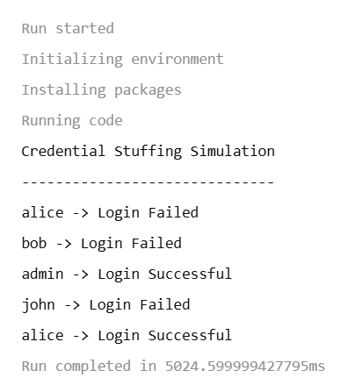
TASK4: Given a login form, implement a simple account lockout mechanism in JavaScript that locks the user out after 3 failed login attempts, similar to what apps like Paytm or PhonePe do for security.<br><br><em><strong>Hint:</strong> Use a counter variable to track failed attempts and disable the login button after 3 tries.</em>
<!DOCTYPE html>
<html>
<head>
<title>Account Lockout</title>
</head>
<body>

<h2>Secure Login</h2>

<label>Username:</label>
<input type="text" id="username"><br><br>

<label>Password:</label>
<input type="password" id="password"><br><br>

<button id="loginButton" onclick="checkLogin()">Login</button>

<p id="message"></p>

<script>

let failedAttempts = 0;

let correctUsername = "admin";
let correctPassword = "Admin@123";

function checkLogin() {

let username = document.getElementById("username").value;
let password = document.getElementById("password").value;
let message = document.getElementById("message");

if (username === correctUsername &&
password === correctPassword) {

message.innerHTML = "Login Successful!";
failedAttempts = 0;

} else {

failedAttempts++;

if (failedAttempts >= 3) {

message.innerHTML =
"Account locked after 3 failed attempts.";

document.getElementById("loginButton").disabled = true;

} else {

message.innerHTML =
"Incorrect login. Attempts remaining: " +
(3 - failedAttempts);
}
}
}

</script>

</body>
</html>
INITIALLY: Failed Attempts = 0
AFTER FIRST WRONG PASSWORD : Incorrect login.
Attempts remaining: 2
AFTER THE SECOND: Incorrect login.
Attempts remaining: 1
AFTER THE THIRD: Account locked after 3 failed attempts.

EXAMPLE :
Attempt | Result
1st wrong password | 2 attempts remaining
2nd wrong password | 1 attempt remaining
3rd wrong password | Account locked
4th attempt | Login button disabled

